Where LLM Portfolio Value Is Created and Lost
Jathin Battepati  Dept. of Computer Science  Aspiring Scholars Directed Research Program  jathin.battepati@students.asdrp.org | Aaryan Parikh  Dept. of Computer Science  Aspiring Scholars Directed Research Program  aaryan.parikh@students.asdrp.org | Huifang Qin  Dept. of Computer Science  Aspiring Scholars Directed Research Program  huifang.qin@asdrp.org

Abstract— Large language models can pick stocks from financial news. This paper measures where a full LLM portfolio pipeline earns its return, layer by layer, and uses that decomposition to find the configuration that keeps it. Across 729 API-generated GPT-5.1 backtest runs over nine overlapping 12-month windows, portfolios built by a two-stage news-and-financials filter beat the S&P 500 by 16.6–22.3 percentage points in every reinvestment configuration (median Sharpe 1.07–1.17 against 0.77), and the model’s stock picks beat random portfolios drawn from its own candidate list (p ≤ 0.008), so the selection carries real information. The decomposition shows where that edge is kept and lost: weighting the selected stocks equally rather than by the model’s conviction weights adds 11.4 points; holding the initial selection for the full year rather than periodically reselecting adds a modest further 3.9–11.0 points; and where reselection is used, trading only the changes rather than liquidating recovers most of its cost. Transaction costs are set to zero, so these differences reflect decision quality, not trading friction. Among the configurations tested, the strongest is also the simplest: LLM selection, equal weights, held for the year.
Keywords—large language models, portfolio management, rebalancing, reinvestment, financial news, buy-and-hold

Introduction
Financial markets continually absorb new information: earnings, product announcements, regulation, and macroeconomic developments can alter a company’s outlook long after a portfolio is formed, so long-term management requires deciding whether the original thesis remains valid as evidence arrives.
Large language models (LLMs) can conduct this information-intensive analysis over unstructured sources — news, earnings discussions, corporate reports — and have been applied to sentiment analysis, return prediction, stock screening, and portfolio construction [2]–[5].
This study extends our earlier two-stage framework [1], in which financial news nominates a candidate pool and financial reports refine it into a long-term portfolio. That paper built the portfolio once and held it; here both stages are repeated at scheduled intervals, so the question shifts from one-time structured selection to the value of continued LLM-driven adaptation over the same 12-month horizon. Only the selection framework is reused: the simulator, the 729 runs, and every result reported here are new to this study.
A static design evaluates the model’s initial prediction, not its ability to operate as an adaptive investment system. The study varies reevaluation frequency, portfolio size, and performance feedback, and asks whether periodic LLM-driven reselection beats an otherwise identical static selection. The distinction is between prediction and adaptation: a model may pick well once yet respond poorly to later developments.
This paper makes three contributions. First, it evaluates periodic LLM reselection against the strategy’s own initial portfolio rather than a market index — a comparison that reverses the conclusion: the framework beats the index but loses to its own first portfolio. Second, it decomposes the pipeline into selection, sizing, and reinvestment and measures the cost of each layer, defined throughout as the mean return foregone relative to the matched portfolio that differs only in that layer; by this measure sizing costs more than reinvestment. Third, it scores every decision against random portfolios drawn from the model’s own candidate shortlist, isolating selection skill from sector exposure.

Methodology
The framework is the two-stage filter of [1]: GPT-5.1 first identifies candidate companies from financial news, then evaluates those candidates against financial statements, historical prices, and market conditions to select the final holdings. Fig. 1 summarizes the pipeline and the layers manipulated in this study.
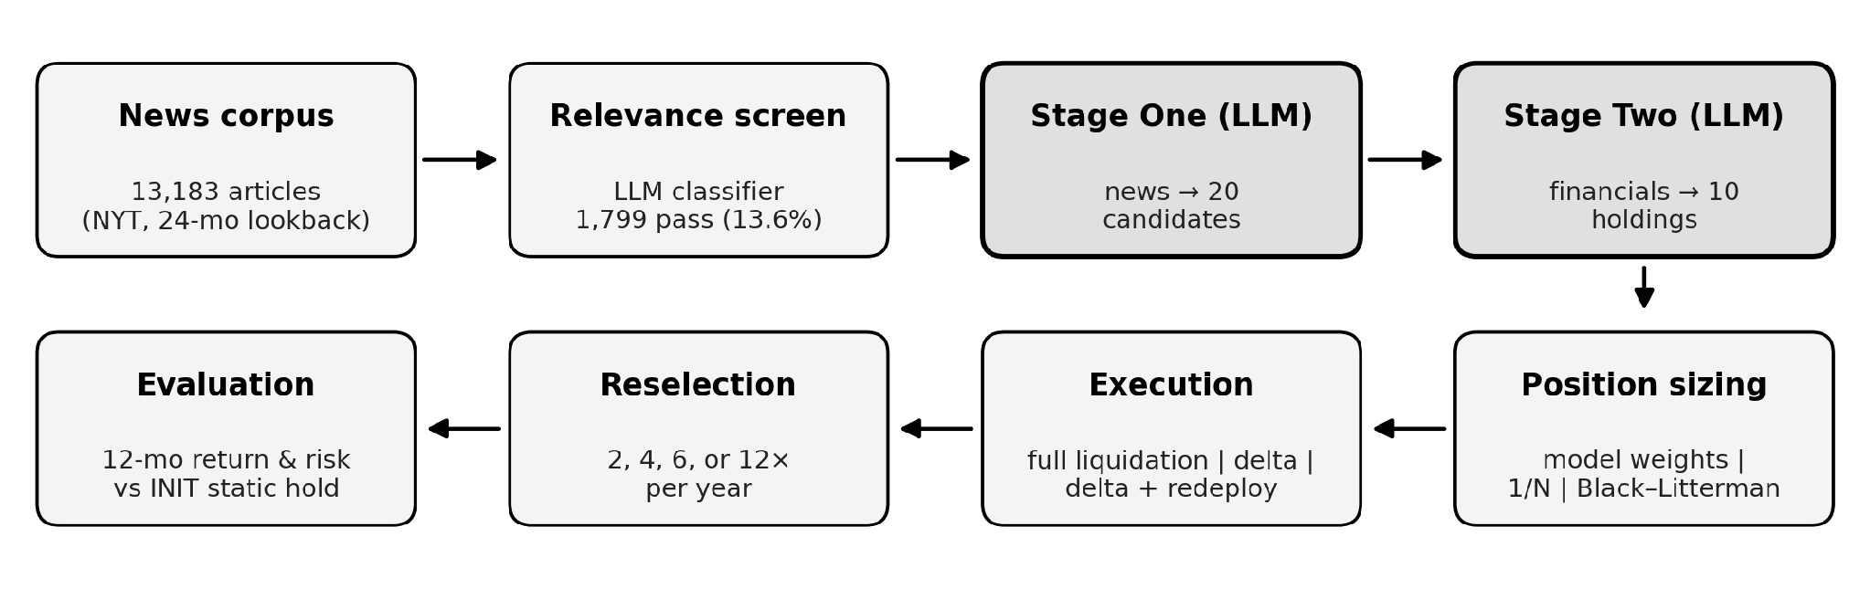
- Two-stage pipeline and the layers manipulated in this study. Stage One and Stage Two are LLM calls; position sizing, execution mechanics, and reselection cadence are varied experimentally, and every arm is evaluated against its own INIT static hold.

Two-Stage Filtering Framework
At each decision date, Stage One received only news headlines and summaries published on or before that date, drawn from a two-year lookback window, so that no article postdating a decision could influence it. The corpus is U.S. technology-sector finance, business, and technology coverage derived from The New York Times, reduced by a separate constrained LLM relevance classifier from 13,183 unique articles to 1,799 (13.6%). Eligible securities were limited to U.S.-listed common stocks, excluding ETFs, indices, OTC securities, foreign listings, and American Depositary Receipts. Decision dates are calendar dates: news is admitted by publication date on or before the decision date (compared date-only), trades execute at the last adjusted close on or before that date, and financial statements are admitted by fiscal period end (or a source-supplied reported date), which can admit a report filed after the decision date. Both artifacts apply identically to every arm and to INIT, and any leaked information arrives at rebalance dates that only the reinvestment arms can act on — so their underperformance of INIT is conservative with respect to them. A filing-deadline rule and next-day execution are planned for the archival version.
Stage Two evaluated the Stage-One candidates using financial-statement summaries, current prices, historical returns, volatility, trend indicators, and macroeconomic context, with statements from a local cache or the Alpha Vantage income-statement, balance-sheet, and cash-flow endpoints. Historical prices were obtained from Yahoo Finance using adjusted daily closing prices, which account for stock splits and dividends, so all returns reported here are total returns. Adjusted closes embed retrospective split and dividend adjustments; the price history shown to the model therefore carries this standard, disclosed artifact.

Experimental Design
The experiment used nine overlapping 12-month evaluation windows beginning monthly from October 1, 2024 through June 1, 2025, and four reinvestment cadences of 2, 4, 6, and 12 reselections per year. All principal arms used a single filtering configuration of 20 initial candidates narrowed to 10 final holdings, so that the reinvestment mechanism rather than the filter width was the manipulated variable. Each window-by-cadence cell was run three times independently, giving 36 cells and 108 runs per arm with no empty cells, so that within-cell variation from model stochasticity could be separated from between-condition effects. These are API-generated backtest runs, not independent market experiments: adjacent windows share eleven months of returns, so the effective number of independent market periods is closer to nine than to the run count (see Statistical Procedure). The supplementary 10→5 arm ran at monthly cadence only (nine windows × three runs) and probes filter width; it enters no headline comparison.
Each portfolio began with $10,000 and permitted fractional-share execution. Transaction costs were set to zero throughout. This is deliberate: it removes trading friction as an explanation for any cadence effect, so differences between reinvestment frequencies reflect decision quality alone rather than the cost of turnover. Model responses were required to follow structured JSON schemas; malformed responses were repaired once or regenerated, and invalid tickers or securities without usable price data were removed before portfolio construction.

Reinvestment Execution
The model expressed each decision as target portfolio weights; a deterministic execution layer converted them into orders, removing budget arithmetic from the model and making overspending structurally impossible. Three execution modes were compared. Under full liquidation, all positions are sold at the latest adjusted closing price and the portfolio is rebuilt from cash to the new target weights. Under delta trading, only the difference between the current and target books is traded: dropped names are sold, added names are bought, and retained positions are left untouched so that appreciation continues to compound. Under delta trading with redeployment, proceeds from exited positions that would otherwise remain uninvested are additionally allocated to retained positions below their target weight.
Arms also varied in how the rebalance decision was framed to the model. The baseline framing states that the previous portfolio has been sold and asks the model to rebuild from cash. An alternative framing states the positions currently held, the interval until the next decision, and an explicit hurdle for replacing an existing holding.

Position Sizing
Because the model assigns conviction weights as part of each decision, sizing and selection are confounded by default. Two alternative sizing rules were therefore applied to the same selected names: equal weighting, which allocates 1/N to each holding, and a Black–Litterman optimizer [9], which treats the model’s weights as views on expected excess return, anchors them to an equilibrium prior implied by the covariance of returns estimated from prices ending strictly before the decision date, and solves for long-only optimal weights. Comparing these against the model’s own weights isolates the contribution of sizing from that of selection. The optimizer uses an annualized covariance of daily log returns from at least 60 trading days ending strictly before the decision date; an equal-weight equilibrium prior (the candidate pool varies per run, so a capitalization prior is undefined); risk aversion δ = 2.5 and τ = 0.05; one absolute view per selected name, anchored on the equilibrium return and scaled by that name’s volatility with view strength 0.02, so a zero tilt means no view; Idzorek-style view uncertainty Ω = diag(τ·PΣPᵀ); and a closed-form posterior followed by a long-only projection. Cells with too few observations, singular covariance, or under two priceable names fall back to equal weight; the 45-cell subset is where all three rules scored without fallback.

Baselines and Benchmarks
The primary baseline, denoted INIT, is the strategy’s own period-0 portfolio held unchanged for the full 12 months. Because the two differ only in whether that selection is subsequently revised, the comparison isolates the reinvestment layer from stock-picking ability. Secondary benchmarks were SPY for the broad market, the S&P 500 Information Technology index and the Nasdaq-100 for sector exposure, and an equal-weighted portfolio of the eligible universe. The equal-weighted universe is reported as a reference point only, since its constituents were assembled with hindsight and it is therefore survivorship-inflated.
In feedback-enabled trials, GPT-5.1 received a summary of its previous holdings, including cost basis, current value, unrealized return, and return since the prior decision date. Control trials were otherwise identical. Daily portfolio value was reconstructed as remaining cash plus the market value of all holdings, and performance was evaluated using return, annualized volatility, Sharpe, Sortino and Calmar ratios, maximum drawdown, beta, and alpha.

Statistical Procedure
The nine evaluation windows overlap and are therefore not independent. All inferential statistics are consequently paired and distribution-free: conditions are compared within each window-by-cadence cell, using the mean of that cell’s three runs as its value, and differences are assessed with an exact sign test and a Wilcoxon signed-rank test; win rates carry exact binomial confidence intervals, and p-values should be read as indicators of effect strength under the matched design rather than exact error rates. Two comparisons were designated primary: each arm against its own INIT baseline, and equal weighting against the model’s conviction weights. All other contrasts are exploratory. At the window level (n = 9), every arm’s mean shortfall against INIT is negative and no arm wins more than four of nine windows; with Holm correction across the six arm-level Wilcoxon tests, the incumbent-framing arms remain significant (adjusted p = 0.023–0.039), the feedback arms are marginal (adjusted p = 0.078), and retained-position — the smallest shortfall — is not significant (p = 0.25). The equal-weighting effect (Wilcoxon p = 3×10⁻²⁴) survives any multiplicity correction.
To separate selection skill from sector exposure, each decision was additionally scored against its own opportunity set. For every rebalance, 10,000 random equal-weighted portfolios were drawn from the Stage-One shortlist that the model had itself produced for that date, and the realized return of the model’s chosen portfolio was expressed as a percentile of that null distribution. Because the opportunity set is held fixed at what the model surfaced, beta, sector composition, and universe construction cannot explain a percentile above 50, which would otherwise confound a comparison against a market index. Both sides of the test are equal-weighted buy-and-hold baskets of identical size, priced by the same last-close-on-or-before convention over the same interval, with unpriceable names excluded identically, so the test isolates selection from sizing by construction.

Results
The framework was evaluated over 729 API-generated GPT-5.1 backtest runs across nine overlapping market windows. Six full arms of 108 runs each varied the reinvestment mechanism with the model, sector, horizon, filter, and windows held fixed; three further 27-run arms probed the filter, the news corpus, and the relevance threshold.

Reinvestment Versus Static Holding
Each arm and its INIT baseline begin from the identical period-0 pick and differ only in whether it is later revised, so the comparison isolates the reinvestment layer (Table I).
- REINVESTMENT ARMS AGAINST THEIR OWN STATIC BASELINE (PP = PERCENTAGE POINTS; †: DELTA-TRADING ARMS CARRYING THE IDLE-CASH DEFECT OF §III-B, RETAINED FOR COMPLETENESS)
Arm | ROI | INIT | vs. INIT | Beats INIT
Feedback off | 37.23% | 46.42% | −9.19 pp | 32/108
Feedback on | 38.56% | 47.46% | −8.90 pp | 33/108
Retained-position | 42.98% | 46.85% | −3.87 pp | 51/108
Incumbent framing† | 38.00% | 46.15% | −8.15 pp | 19/108
Incumbent + invested† | 38.63% | 49.61% | −10.98 pp | 18/108
Incumbent + redeploy | 42.44% | 50.65% | −8.21 pp | 31/108
Every arm underperformed its own static baseline. The strongest configuration, retained-position execution — the delta-trading arm in which retained holdings are never sold and repurchased — lost 3.87 percentage points and was the only arm whose shortfall was not significant at the 0.05 level (Wilcoxon p = 0.067); all remaining arms underperformed at p < 0.05. The direction is unanimous at the window level (see Statistical Procedure).

Reinvestment Frequency and Execution
Because transaction costs were set to zero, cadence effects here reflect decision quality rather than trading friction. Under retained-position execution the shortfall against INIT was −8.91 pp at two reselections per year, −2.68 pp at four, −2.79 pp at six, and −1.11 pp at twelve. More frequent reselection was better, not worse: a bad semiannual substitution compounds for six months; a monthly one is revised within weeks.
Execution mechanics mattered more than cadence. Replacing full liquidation with delta trading, in which retained positions are left untouched and only the difference between the current and target books is traded, improved returns by 4.42 pp (27 of 36 cells, Wilcoxon p = 0.0001). A defect in the delta-trading path was identified during analysis: proceeds from exited positions were deployed only into newly added names, so any decision that dropped a holding without adding one stranded that capital as idle cash. Redeploying those proceeds into retained positions recovered a further 3.81 pp (p = 0.0014) and reduced mean idle cash from 6.51% to 2.68% (p = 7×10⁻¹⁰).

Performance Feedback
Feedback on prior holdings improved return by 1.32 pp on average (25 of 36 cells; sign p = 0.029, Wilcoxon p = 0.062); effects on Sharpe (+0.03, p = 0.203) and on the INIT margin (+0.28 pp, p = 0.509) were null. The clearer effect was behavioral: with feedback the model retained positions that went on to return 6.5% while dropping ones returning 3.7% (a 2.8 pp discrimination gap, against −0.5 pp without) — feedback changed what was kept without reliably improving return.

Selection Skill Against the Model’s Own Candidate Pool
Each decision was scored against 10,000 random equal-weighted portfolios drawn from the Stage-One shortlist the model had itself produced, as described above; a percentile of 50 indicates no skill (Table II).
- SELECTION SKILL AGAINST THE MODEL’S OWN CANDIDATE POOL
Arm | Median pct. | Beat pool | Initial buy | Reselection
Retained-position | 54.1 | 346/648 | p = 0.18 | p = 0.0001
Feedback on | 52.1 | 343/646 | p = 0.57 | p = 0.0079
Feedback off | 49.5 | 316/645 | p = 0.76 | p = 0.042
Selection skill is real but concentrated in reselection; initial picks do not differ from chance in any arm. Because the null is drawn from the model’s own shortlist, the skill localizes to Stage Two’s ranking (candidate generation is held fixed and not assessed). The edge tracks feedback: disabling it removes significance.

Position Sizing
Replacing the model’s conviction weights with equal weights over the same selected names improved returns by 11.42 pp (134 of 144 cells, Wilcoxon p = 3×10⁻²⁴). On the 45-cell subset where all three sizing rules could be scored, a Black–Litterman optimizer [9], which uses the language model for return views and delegates sizing to an optimizer, recovered most of the equal-weight gain on that subset (+7.52 pp of 8.29 pp over model weights) but remained significantly worse than equal weighting (−0.77 pp, p = 2×10⁻⁷). Position sizing was the single largest source of lost return measured in this study, exceeding the cost of reinvestment itself (Fig. 2).
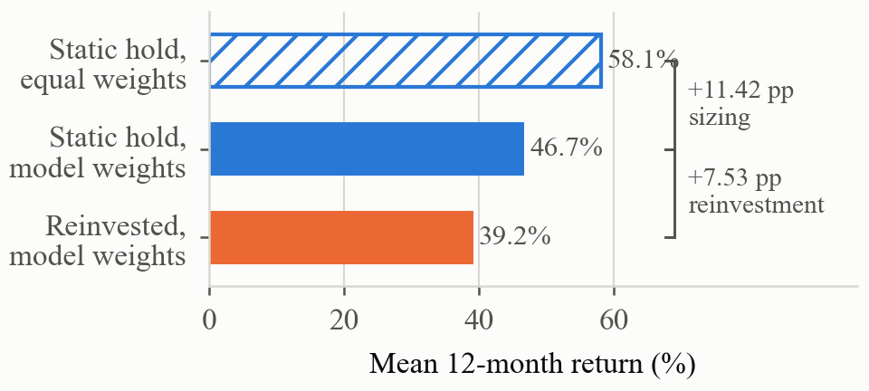
- Where the return is lost. The same period-0 selections under three treatments, pooled over 432 runs and 144 window-by-cadence cells. Revising the selection costs 7.53 pp; sizing it by the model’s conviction weights rather than equally costs a further 11.42 pp.

Mechanism: Truncation of the Return Distribution
Reinvestment reduced dispersion on a right-skewed opportunity set. The rebalanced portfolios had standard deviation 13.30 and skewness +0.76 with a maximum of +76.28%, against 20.63, +1.61 and +142.80% for the static baseline (Fig. 3). Upside capture was 70% when the static baseline landed in its best quartile and 105% when it landed in its worst. A counterfactual sweep is consistent with the mechanism: every rule that trimmed a compounding position lost ground against holding without intervention, from −0.16 pp for the mildest position cap to −22.88 pp for the most aggressive gain trim, with the loss growing in aggressiveness within each family of rules.
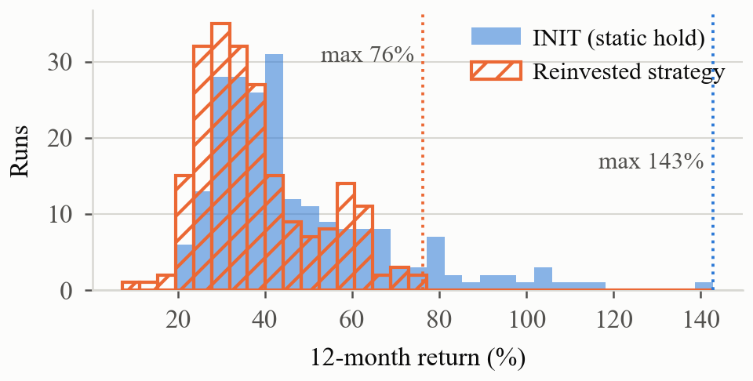
- Distribution of 12-month return over 216 runs. Reinvestment compresses the right tail: the static baseline reaches +142.80% while the rebalanced portfolios stop at +76.28%.

Benchmark Comparisons
Against SPY the framework outperformed by 16.56 to 22.30 pp and won every paired cell, but this reflects sector exposure, not selection: the portfolios are large-capitalization technology and semiconductor names in a period of strong sector appreciation. Against the S&P 500 Information Technology index the margin narrowed to 1.74–7.49 pp, significant only for the stronger arms, and every arm underperformed the equal-weighted eligible universe by 17.40–23.14 pp. Risk-adjusted performance tells the same story: median Sharpe (zero risk-free basis) runs 1.07–1.17 across arms versus 0.77 for SPY, at higher volatility (24–27% against 17%) and deeper drawdowns (≈−22% against −14%); INIT beats every arm here too (median Sharpe 1.26 at comparable volatility and drawdown), so the static hold wins risk-adjusted as well.

Sensitivity to the News Corpus
Three corpora were compared at monthly cadence over all nine windows (three runs per cell). The static baseline returned 45.60% on the relevance-screened corpus, 47.60% on a graded-score corpus retaining a comparable 11.9% of articles (+2.00 pp, p = 0.426), and 51.91% unscreened (+6.31 pp, 7 of 9 windows, p = 0.039). Relaxing the filter did not reduce selection quality — but the contrast is confounded. The paths differ in mechanism, not merely threshold — the unscreened path applies a literal sector-keyword match overlapping the screened set on only 13% of articles; a graded-scale sweep is future work.

Discussion
Judged against a market index the framework succeeds; judged against its own initial portfolio held untouched, it falls modestly short. The gap is the reinvestment layer, not stock-picking ability; the index comparison alone would credit it with sector appreciation it did not generate.
Both layers above selection are costly, and sizing costs more than reinvestment: equal weighting recovered 11.4 percentage points, exceeding the 3.9-point penalty of the best reinvestment configuration, and Black–Litterman — the standard remedy — did not beat equal weighting. In the tested GPT-5.1 technology-sector portfolios, conviction weights should not be treated as calibrated position sizes without separate validation; equal weighting is the strongest of the rules compared here, not necessarily the best sizing rule in general.
The evidence is consistent with a distributional mechanism: the opportunity set is strongly right-skewed, and trimming compounding positions truncates the tail that produces the return. A per-decision attribution over 1,610 rebalance decisions agrees: dropped names subsequently outperformed added names in every arm, with the cost concentrated at infrequent cadences (−4 to −6.5 pp per swap semiannually versus roughly zero monthly), though the mean effect (−0.25 to −0.33 pp per decision) is not individually significant. Prior work treats turnover as a cost to be managed [6], [7], and cost-inclusive LLM studies favor infrequent reselection [10]; with costs excluded here the frequency ordering reflects decision quality, and in a mean-reverting regime the sign should reverse. The results echo reports that LLM trading advantages shrink under broader evaluation and that buy-and-hold is among the strongest long-horizon baselines [8].
Limitations: the nine windows overlap, so the effective sample is far smaller than the run count; the study covers one sector in a strongly appreciating regime, where right-tail truncation costs most; returns exclude transaction costs, taxes, and slippage, which would compress the cadence ordering; and the relevance classifier is a smaller model validated for precision, not downstream return.
Reproducibility: all runs used the OpenAI API alias “gpt-5.1” (July 31–August 4, 2026; provider-default decoding); each run record retains its daily value series, per-period decisions, and risk metrics. The simulator, prompts, schemas, retry and validation logic, relevance-classifier prompt, and full run corpus are public at https://github.com/JathinBat/ASDRP-LLM-Long-Term-Investment-Strategy.

Conclusion
Periodic LLM-driven reselection did not improve on holding the same model’s initial portfolio: across 729 backtest runs, all six reinvestment configurations underperformed its own static baseline while outperforming a broad market index by a wide margin. Both comparisons matter: the market margin shows the pipeline is profitable, while the static-baseline comparison isolates the effect of reselection itself.
The framework contains a measurable edge: scored against its own candidate shortlist, the model selects above chance, most strongly with feedback — but the skill sits in reselection, not the initial purchase where the capital is committed, and the machinery above it removes more value than selection creates. Future work should target the initial selection, richer sizing rules, reinvestment policies beyond those tested, and regimes that are not strongly right-skewed. The contribution is a diagnosis: value is created in selection and lost in sizing and reinvestment, and among the configurations tested the strongest deployment is the simplest — equal-weighted, bought once, and held.

References

- J. Battepati, R. Fernandes, A. Parikh, S. Chappidi, S. Nirmale, S. Bhasin, S. Chhabria, and H. Qin, “Improving the performance of long-term stock investments with a two-stage LLM filtering framework,” submitted for publication, 2026.
- O. Romanko, A. Narayan, and R. H. Kwon, “ChatGPT-based investment portfolio selection,” Oper. Res. Forum, vol. 4, art. 91, 2023.
- G. Fatouros, K. Metaxas, J. Soldatos, and D. Kyriazis, “Can large language models beat Wall Street? Unveiling the potential of AI in stock selection,” Neural Comput. Appl., 2024.
- T. Guo and E. Hauptmann, “Fine-tuning large language models for stock return prediction using newsflow,” arXiv:2407.18103, 2024.
- N. Anic, A. Barbon, R. Seiz, and C. Zarattini, “ChatGPT in systematic investing: Enhancing risk-adjusted returns with LLMs,” arXiv:2510.26228, 2025.
- M. Kritzman, S. Myrgren, and S. Page, “Portfolio rebalancing: A test of the Markowitz–Van Dijk heuristic,” MIT Sloan Research Paper No. 4641-07, 2007.
- A. W. Lynch and P. Balduzzi, “Predictability and transaction costs: The impact on rebalancing rules and behavior,” J. Finance, vol. 55, no. 5, pp. 2285–2309, 2000.
- W. W. Li, H. Kim, M. Cucuringu, and T. Ma, “Can LLM-based financial investing strategies outperform the market in long run?” arXiv:2505.07078, 2025.
- Y. Lee, Y. Kim, J. Kim, S. Kim, and Y. Lee, “LLM-enhanced Black–Litterman portfolio optimization,” arXiv:2504.14345, 2025.
- L. A. Mantshimuli and J. W. Muteba Mwamba, “Few-shot portfolio optimization: Can large language models outperform quantitative portfolio optimization? A comparative study of LLMs and optimized portfolio allocators,” J. Risk Financial Manag., vol. 19, no. 5, art. 320, 2026.

